**Simple BERT Models for Relation Extraction and Semantic Role Labeling**

1 Introduction

Relation extraction and semantic role labeling (SRL) are two fundamental tasks in natural language understanding. The task of relation extraction is to discern whether a relation exists between two entities in a sentence. For SRL, the task is to extract the predicate–argument structure of a sentence.

State-of-the-art neural models for both tasks typically rely on lexical and syntactic features, such as part-of-speech tags, syntactic trees, and global decoding constraints.

2 BERT for Relation Extraction

2.1 Model

For relation extraction, the task is to predict the relation between two entities, given a sentence and two non-overlapping entity spans.

First, we construct the input sequence [[CLS] sentence [SEP] subject [SEP] object [SEP]]. The input is then tokenized by the WordPiece tokenizer and fed into the BERT encoder.

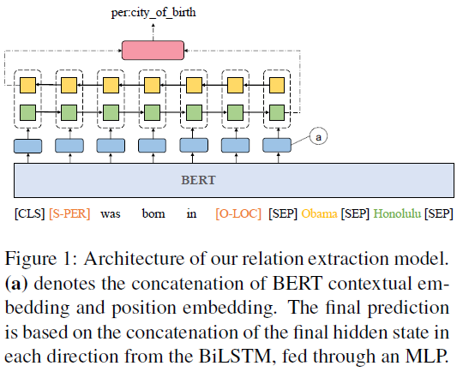

2.2 Experiments

3 BERT for Semantic Role Labeling

3.1 Model

The standard formulation of semantic role labeling decomposes into four subtasks: predicate detection, predicate sense disambiguation, argument identification, and argument classification.

There are two representations for argument annotation: span-based and dependency-based.

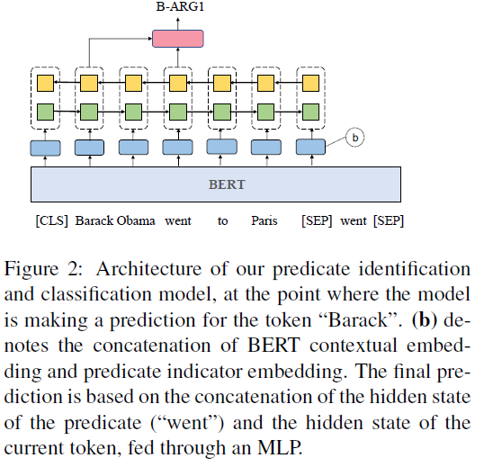

**Predicate sense disambiguation**. The predicate disambiguation task is to identify the correct meaning of a predicate in a given context.

**Argument identification and classification.** This task is to detect the argument spans or argument syntactic heads and assign them the correct semantic role labels.

Formally, our task is to predict a sequence z given a sentence–predicate pair (X, v) as input, where the label set draws from the cross of the standard BIO tagging scheme and the arguments of the predicate.

3.2 Experimental Setup

3.3 Dependency-Based SRL Results

3.4 Span-Based SRL Results

4 Conclusions

Based on this preliminary study, we show that BERT can be adapted to relation extraction and semantic role labeling without syntactic features and human-designed constraints.